The Chinese University of Hong Kong

Department of Computer Science and Engineering

CENG2030 Fundamentals of Embedded System Design

Lab 5: Operational Amplifier

Answer Sheet

Student Name:Wong Wai Chun SID: 1155173231

1. **Inverting Amplifier [55%]**
   1. Create and upload your TSC circuit file. [10%]
   2. Analysis of Inverting Amplifier (Please state the **unit** clearly for each parameter)

Output Voltage VF2 (Vpp): _____12V_____ [5%]

Gain in dB: $A=20log\frac{Vout}{Vin}$ = __20log(6/3)= 6.02059991328___ [5%]

When Vin is positive, Vout is _______Negative___________ [5%]

V-: _____0V______ [5%]

V+: _____0V______ [5%]

VDIFF: _____0V______ [5%]

IR1: ___3mA_______ [5%]

IR2: ___3mA_______ [5%]

Equation: IR1 = _______Ir2__________________ [5%]

1. **Active Low Pass Filter [45%]**
   1. Create and upload your TSC circuit file. [10%]
   2. Analysis of Active LPF
      1. Collected Data [12%]

|  |  |  |  |  |  |  |  |  |  |  |  |  |
| --- | --- | --- | --- | --- | --- | --- | --- | --- | --- | --- | --- | --- |
| Frequency of VF1  (Hz) | 50 | 100 | 200 | 500 | 1k | 2k | 5k | 10k | 20k | 50k | 100k | 200k |
| Vpp of VF2  (V) | 12 | 12 | 12 | 10 | 8 | 4.4 | 4 | 1 | 0.4 | 0.2 | 0.1 | 0.05 |

* + 1. Cut-off Frequency

fc: $fc=\frac{1}{2πCR_{2}}$ = __ 795.77471____ D [5%]

Vout at fc: ___8V________ [5%]

* + 1. Graph Plotting [13%]

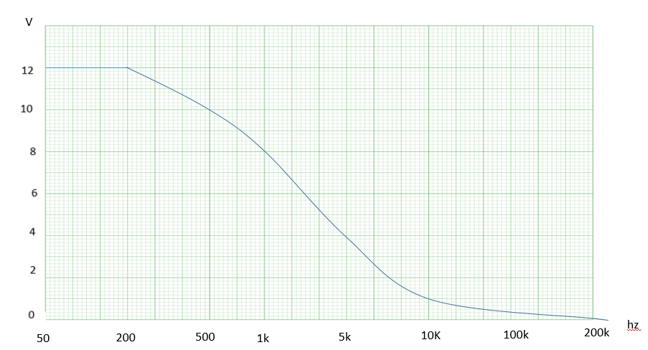THE END